סיכוםMySQL -

קורס FULLSTACK

Table of Contents

MySQL Basic 3

· SELECT 3

· WHERE 3

o The AND, OR and NOT Operators 3

o WHERE NOT Operator 3

o The IN Operator 3

o BETWEEN Operator 3

o LIKE Operator % 4

o LIKE Operator _ 4

o NOT LIKE Operator 4

o REGEXP 4

o IS NULL 4

· ORDER BY 5

· LIMIT 5

Joins 5

· INNER JOIN 5

· JOIN Across databases 5

· Self join 6

· Joining Multiple Tables 6

· USING Clause 6

· Left join 7

· Right join 7

· CROSS JOIN 7

DML 7

· INSERT 7

· UPDATE 8

· DELETE 8

Summarizing data 8

· Aggregate Functions 8

· Count 9

· Group by 9

· Having Clause 9

Views & Stored Procedures 10

· Views 10

· Sored Procedures 10

o Stored Procedures with parameters 11

o Add 11

Design Database 12

# MySQL Basic

## SELECT

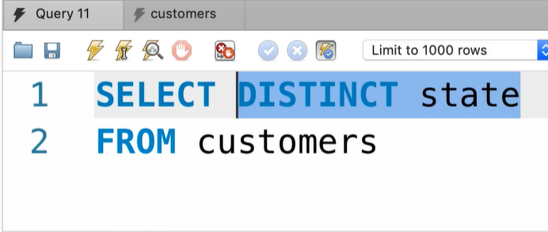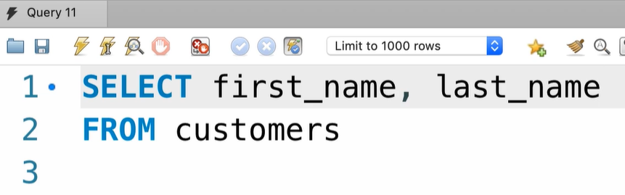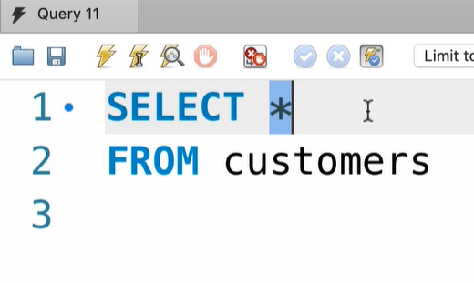

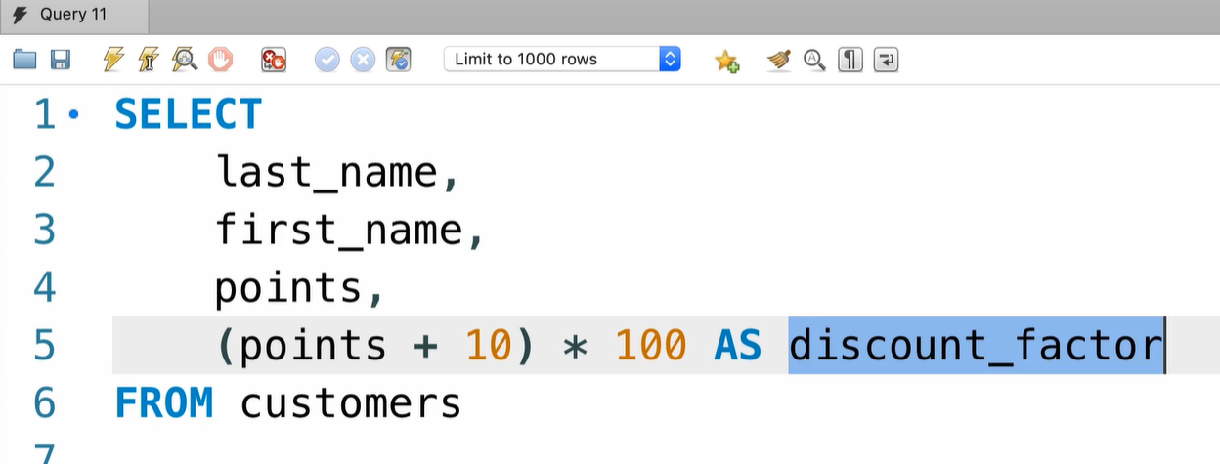

## WHERE

### The AND, OR and NOT Operators

### WHERE NOT Operator

### The IN Operator

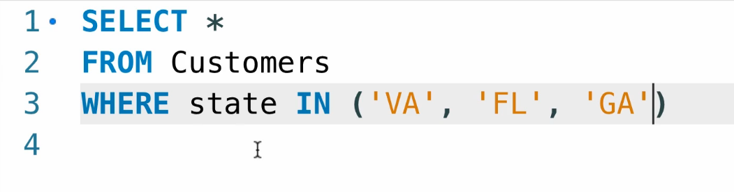

### BETWEEN Operator

### LIKE Operator %

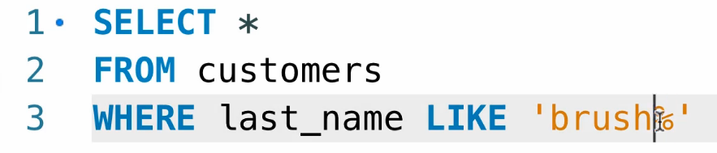

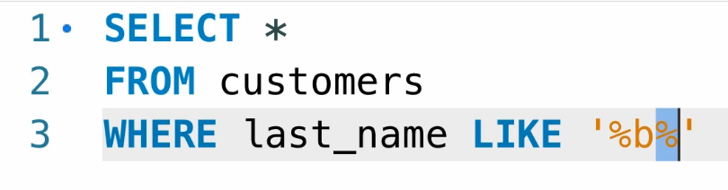

### LIKE Operator _

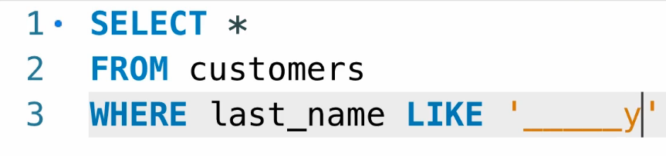

### NOT LIKE Operator

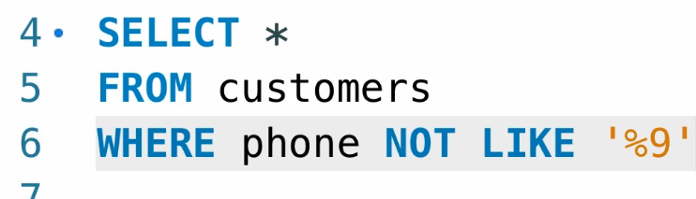

### REGEXP

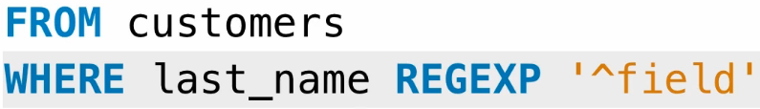





### IS NULL



## ORDER BY

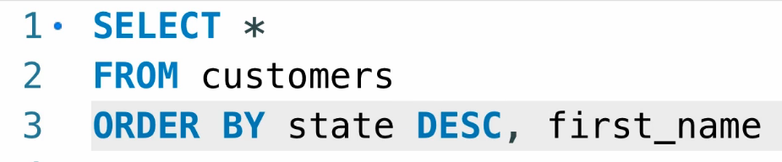

## LIMIT

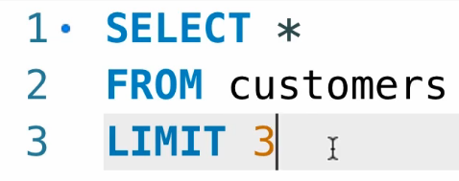

# Joins

## INNER JOIN

Select columns from multiple tables.  
When we want to combine data from mutable tables we use JOIN

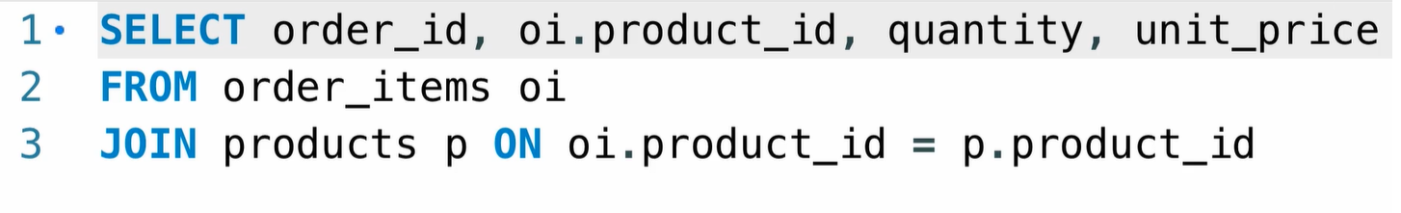

## JOIN Across databases

Combine columns in tables cross multiple databases

USE keyword to set the database that we already use

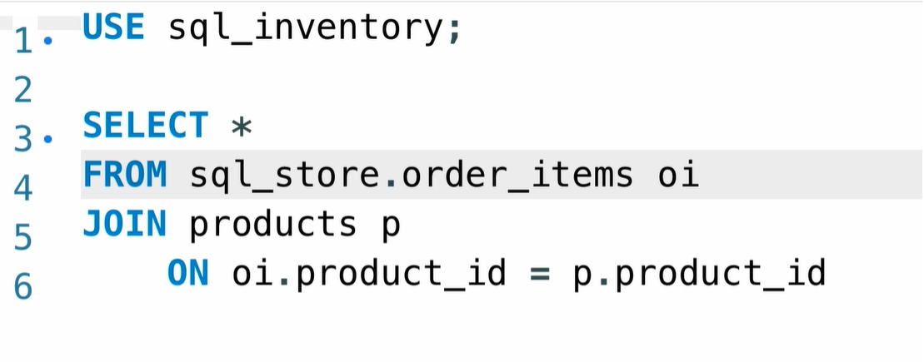When we are using table that is not in the current selected database when should add as prefix the database name before the table

## Self join

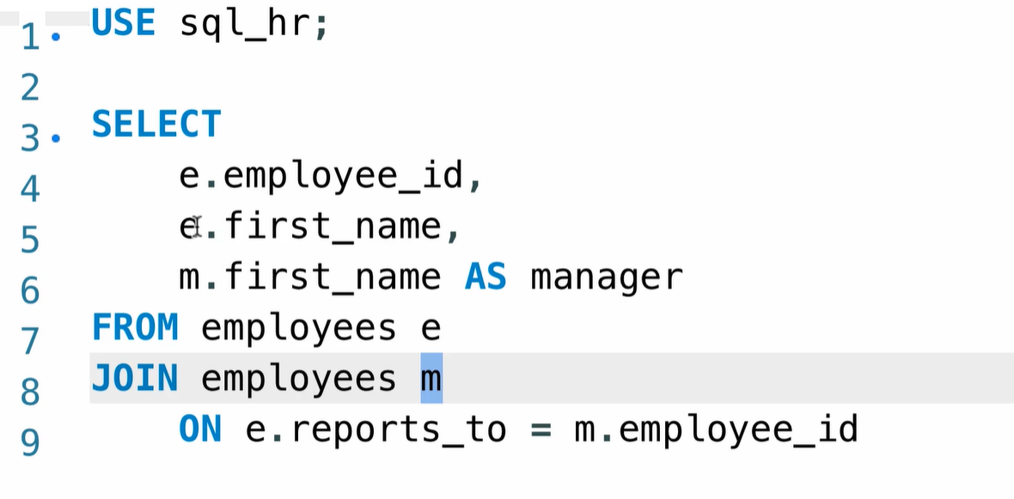

## Joining Multiple Tables

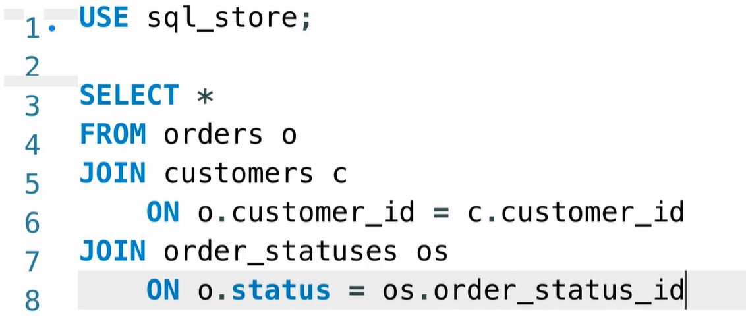

## USING Clause

* In both tables we have the same column name
* The same column shipper_id & customer_id in both customers and shippers

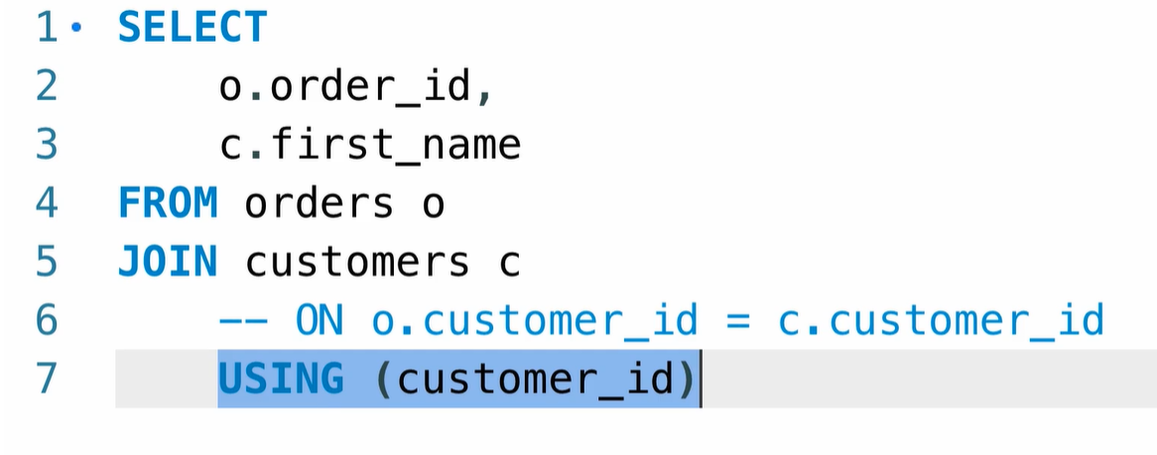

## Left join

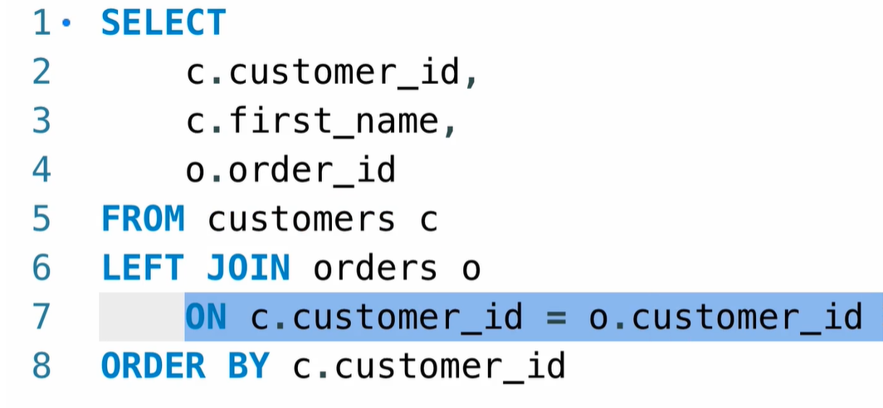**Left join**, all the record will return whether if the condition true or not. In the example below the all the data from the customer table will be returned

## Right join

**Right join**, all the record from the order table will be retuned whether the condition is true or not

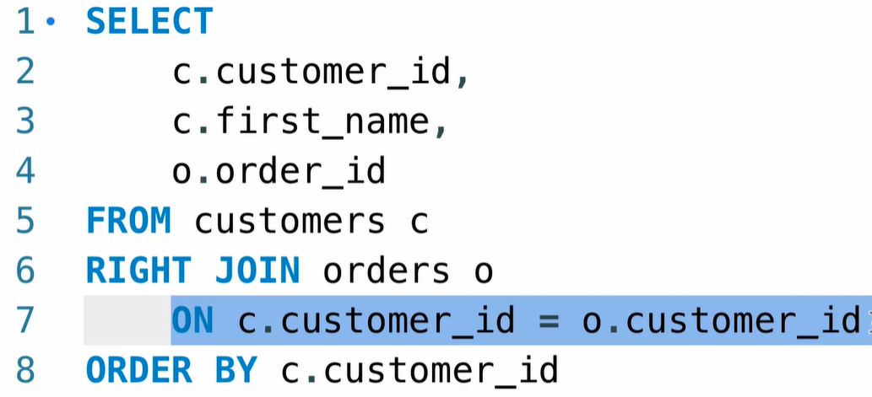

## CROSS JOIN

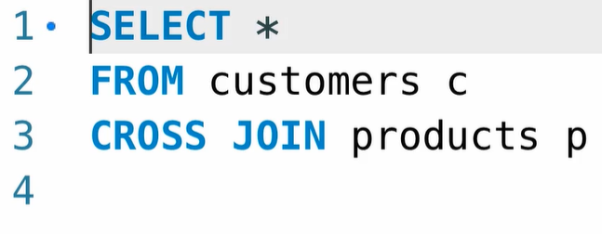**CROSS JOIN**, every record from the customer table will be combined with every record from the product table, because of that we don’t have ON

# DML

## INSERT

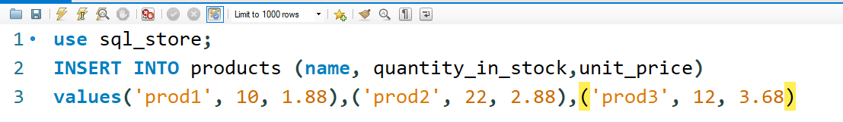

## UPDATE

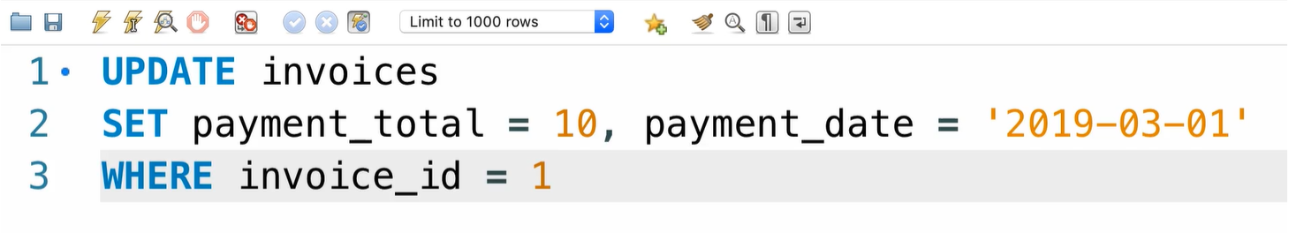

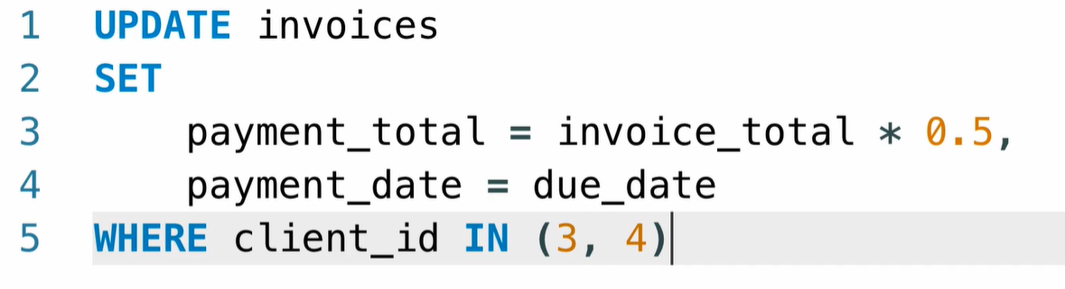

## DELETE

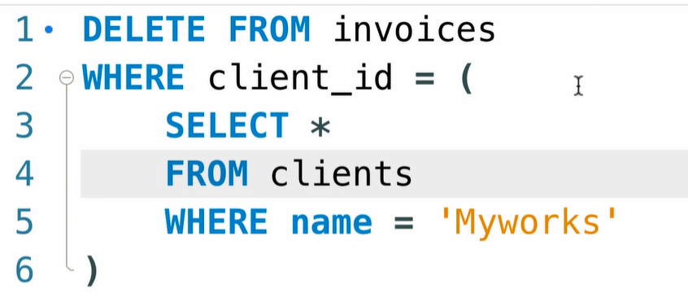

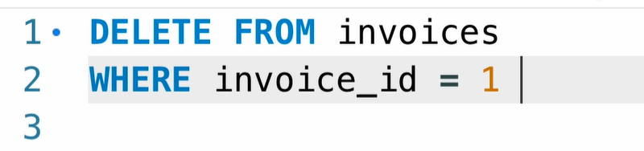

# Summarizing data

## Aggregate Functions

Aggregation function called aggregate function because they take a series of values and aggregate them to produce signal value

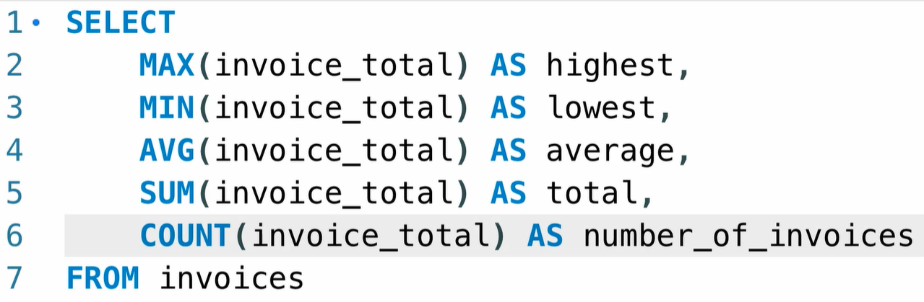MYSQL Build in Aggregations functions

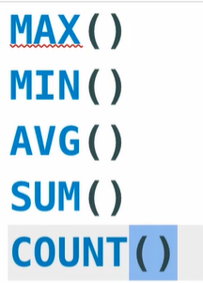

## Count

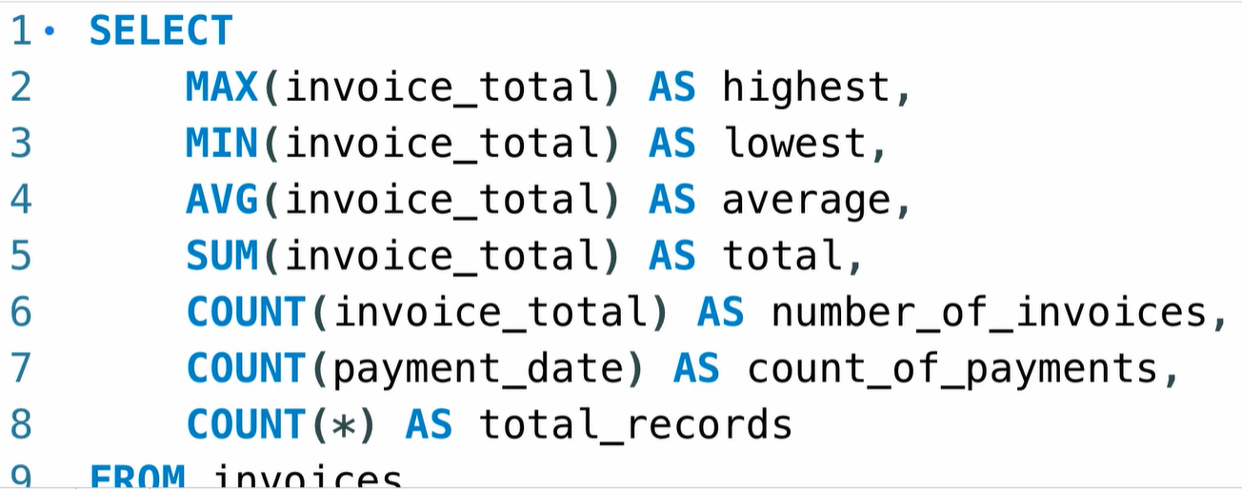

## Group by

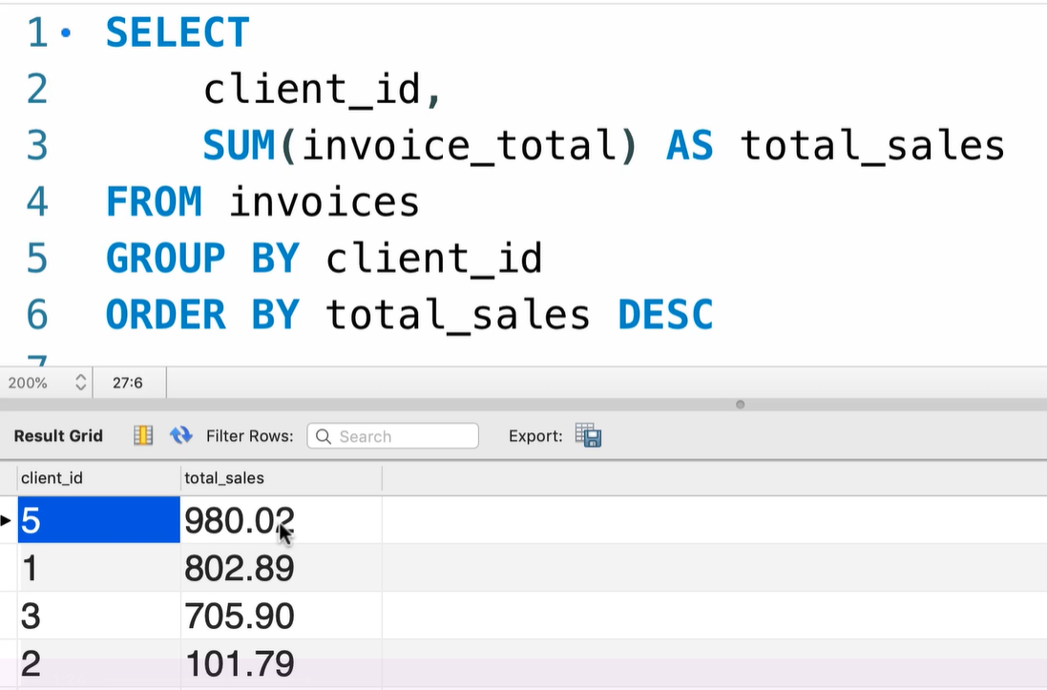

## Having Clause

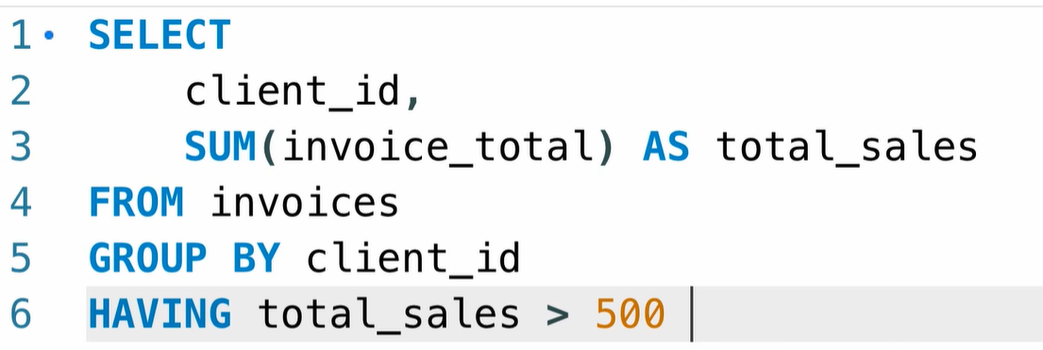

# Views & Stored Procedures

## Views

Reduce the impact: when u change the column name u just need to change the view because everything else depend on the views and not the table, because good design based on the views only and don’t work directly on the tables

Restrict access: we can return some of the data not all the data that we have in the table

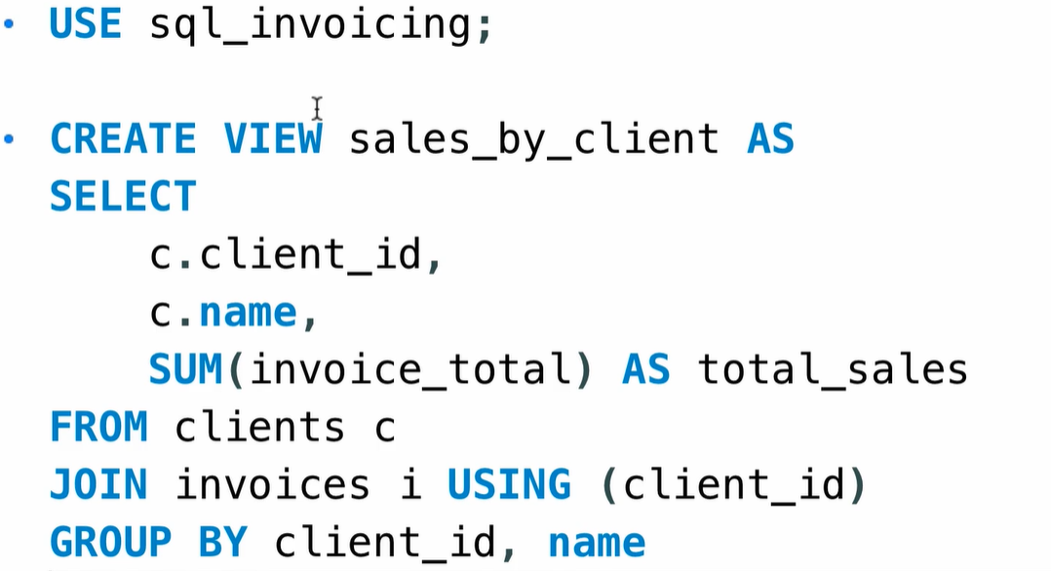



## Sored Procedures

SQL statement? You’re not going to write them in your application code for couple of reasons. One reason is it will make your application code messy and hard to maintain.

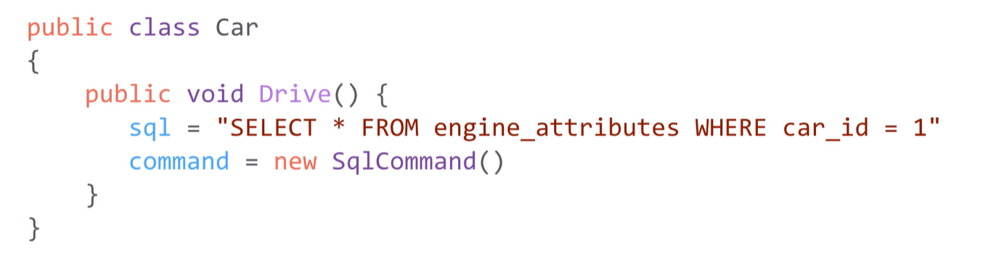Once u have top change the sql u don’t need to compile the code

## 

### Stored Procedures with parameters

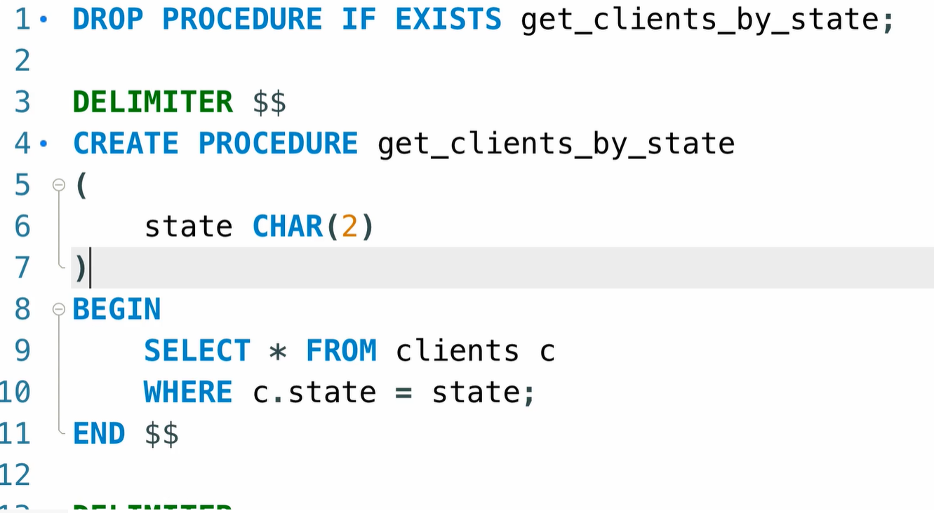



### Add

